**Assignment 3**

**Rasika Mohod**

rmohod@gmu.edu

G01044774

Implementation is done using 2 files: ***IntSet.java and IntSetClient.java***

Junit test is performed using 1 test file: ***IntSetTest.java***

**Output after running IntSetClient.java:**

Before insertion of elements in set:

Currently there are no elements in the IntSet

After insertion of elements in set:

Input elements to be inserted in set 1: null

Elements given to be inserted in set are null. Please enter valid elements.

-----------------------------------------------------------

Input elements to be inserted in set 2: 1 45 -9 56 34 45

Integer 45 cannot be inserted as it already exists in the set.

The IntSet is: [-9, 1, 34, 45, 56]

-----------------------------------------------------------

Input elements to be inserted in set 3: 10 45 9 -99 6 33 -8

The IntSet is: [-99, -8, 6, 9, 10, 33, 45]

-----------------------------------------------------------

Enter number of elements to be inserted in set 4: 4

Enter element to inserted: 2

Enter element to inserted: 1.4

Only integer values are expected.Please enter valid integer.

Enter element to inserted: 1

Enter element to inserted: -2

Enter element to inserted: 1

Integer 1 cannot be inserted as it already exists in the set.

Enter element to inserted: 5

The IntSet is: [-2, 1, 2, 5]

-----------------------------------------------------------

**Output after running Junit Test case file (IntSetTest.java)**

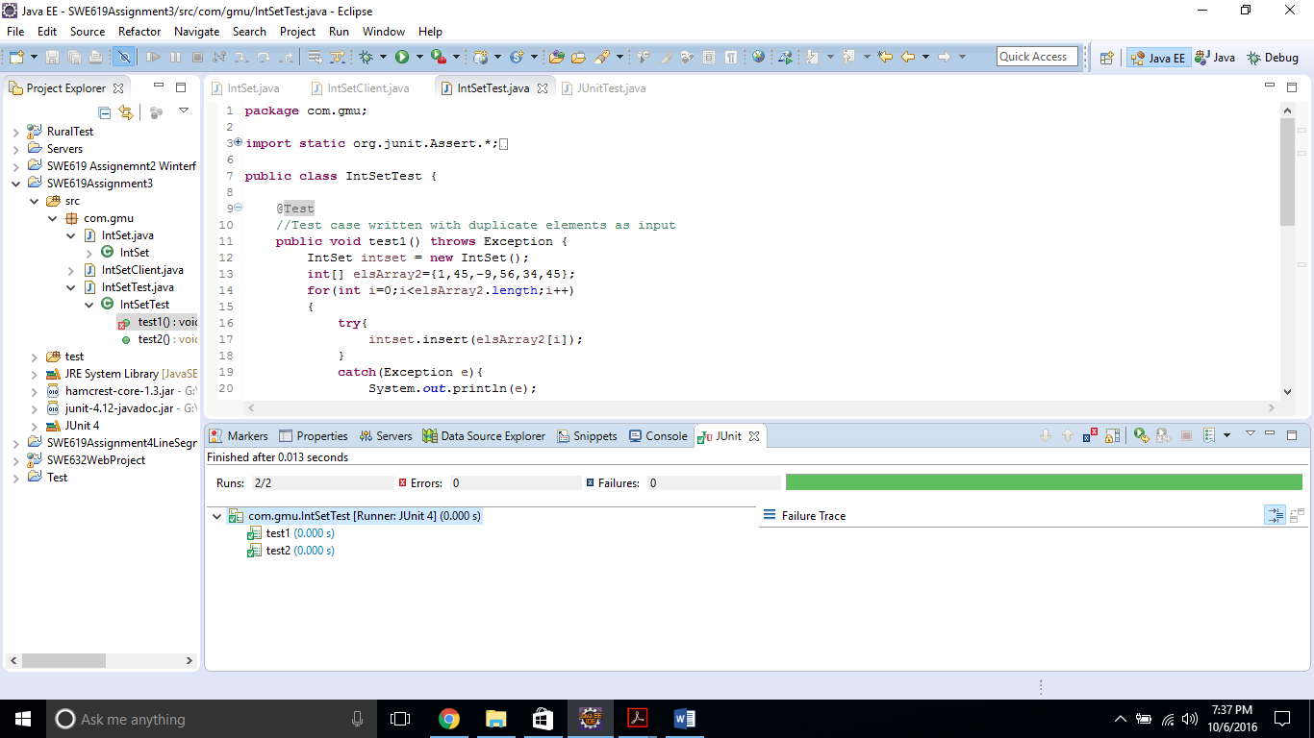

**test1():**

Input elements = 1,45,-9,56,34,45 ;

* The code inserts each element and keeps the set sorted.
* The code checks if new element to be inserted already exists in the set or not.
  + If yes, it discards the element and notifies the user and continues inserting remaining elements (thus here the last input element ‘45’ is not inserted as it already exists in the set.)
  + If no, it inserts the element.

Output: The IntSet is: [-9, 1, 34, 45, 56]

**test2():**

Input elements = 10,45,9,-99,6,33,-8;

* The code inserts each element and keeps the set sorted.
* The code checks if new element to be inserted already exists in the set or not.
  + If yes, it discards the element and notifies the user and continues inserting remaining elements (in this case no element is repeated).
  + If no, it inserts the element.

Output: The IntSet is: [-99, -8, 6, 9, 10, 33, 45]